Buy the Dip … we expect another solid
S&P 500 Index
Jan – Dec 2025
year of returns for 2026.
5000
5500
6000
6500
7000
Trump Inauguration
US tariffs on China, Canada, Mexico
‘Liberation Day’
90-day tariff pause
US and UK
trade deal
Trade deals reached with Indonesia, Japan, EU and others
China rare earth controls

Government Shutdown
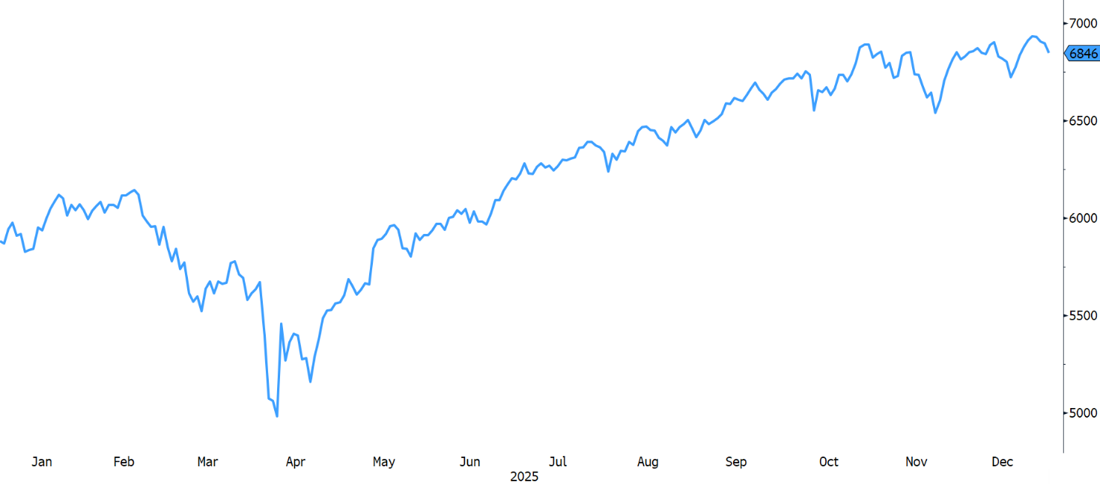
As shown by the chart to the right of the S&P 500 last year, we expected a good but more volatile year compared to 2024 and that’s what played out. The Trump administration’s first half focus on tariffs and deportations fanned market anxiety over inflation and a recession, which caused the S&P 500 to plunge 21% on an intra-day basis from February through early-April.
However, as the spring progressed, trade deals were reached (at lower rates than initially threatened) and wage inflation never materialized to any significant extent. The stock market staged a rally from April that lasted for the rest of the year. Investors were also cheered by a resilient US economy that posted above-average second and third quarter growth of +2.8% and +4.4%, respectively. More recently, the US economy is forecast to have grown at a stellar +5.4% real rate for the fourth quarter of 2025, which includes an estimated 1.0-1.5% GDP drag from the longest US government shutdown on record (43 days from October 1st to Nov 12th). The strong US economy reflects moderating inflation and the pro-growth, pro-business policies passed by the Trump Administration in July, which included full expensing of capital equipment spending in year one plus tax and regulatory relief.
Jan
Feb
Apr
Mar
May
Jun
Jul
Aug
Sep
Oct
Nov
Dec
Source: VGA, data sourced though Bloomberg
Corporate earnings growth has also been extraordinary. S&P 500 earnings rebounded 21% on a year-over-year basis in the third quarter of 2025 with full year 2025 earnings growth projected at +12.9% - almost 50% higher than the long-run average of 8.7% per year. For 2026, Standard & Poor’s analysts currently forecast S&P 500 earnings will grow 17.9%, albeit this figure tends to moderate as the year progresses.

While our belief is that the odds favor another good year for investors in 2026, we anticipate a significant pullback of 10-15% based on valuation concerns. Given the favorable investment backdrop, we believe such a pullback could be a buying opportunity.

In short, we believe the PROs continue to outweigh the CONs heading into the new year. Specifically:
PROs:
- Solid US Economy: +4.4% 3Q’25, +5.4% 4Q’25, 3.0%+ for 2026:
- Resilient US Consumer: Low 4.3% unemployment, 3-4% real consumer spending
- Moderating Inflation: +2.7% in December vs. 2.9% one year earlier. For 2026: 2.4% to 3.2%
- Renewed Fed Easing: 2-3 more interest rate cuts, $40 billion/mo liquidity injections (QE Lite)
- Strong Earnings: +13% in 2025, +14-15% for 2026
- Strong Market Breadth: S&P 500 Advance-Decline line hitting all-time highs
- Bullish Analogs:
        - Average post-WW II bull market has gained 155% over 4.5 years vs. current gain of 93% over 3.3 years 32% further gain into the spring 2027.
        - Dot-com vs. AI Bull Market Analog – further to run
        - Renewed Fed Easing Cycle – historic analog suggests +14.1% gain for 2026
        - Years that follow years like 2025 14.7% gain over next 12 months
- VGA Macro Models: BULL or MAX BULL currently S&P 500 +11-17% per year in these zones vs. 10% over the long-run.

CONs:
- Valuation Reset Stocks are not cheap
- S&P 500 (market-cap weighted) – 22x 2026 eps (vs. 19x normal) 14% pullback to “re-set”
- S&P 500 (equal-weighted) – 17x 2026 eps (vs. 16x normal) 6% pullback to “re-set”
        - Average year 13.7% pullback since 1980 (yet, 83% positive)
- Interest Rate Spike Monitor UST auctions, risk metrics
- AI Job Losses Monitor initial jobless claims
- Black Swan Events Geopolitical, Cyber Attacks

In the following section, we highlight several interesting charts, tables and data behind some of the PRO’s and CON’s we have listed above, along with commentary on each.

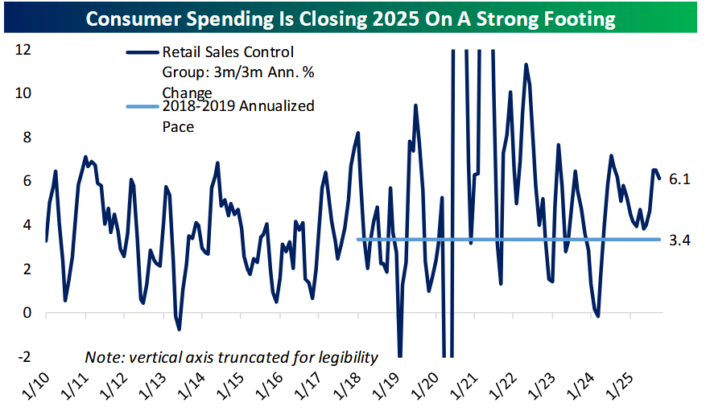
PRO – Solid US Economy ex-AI Boom

Not only did the US economy grow 2.8% and 4.4% in the second quarter and third quarters of 2025, but it is also forecast to have grown at a +5.4% pace in the 4Q’25. A common criticism is that the strength of the US economy is entirely due of the AI spending boom. However, the two charts to the left show that the US consumer remains a clear source of economic strength despite the AI-driven narratives.

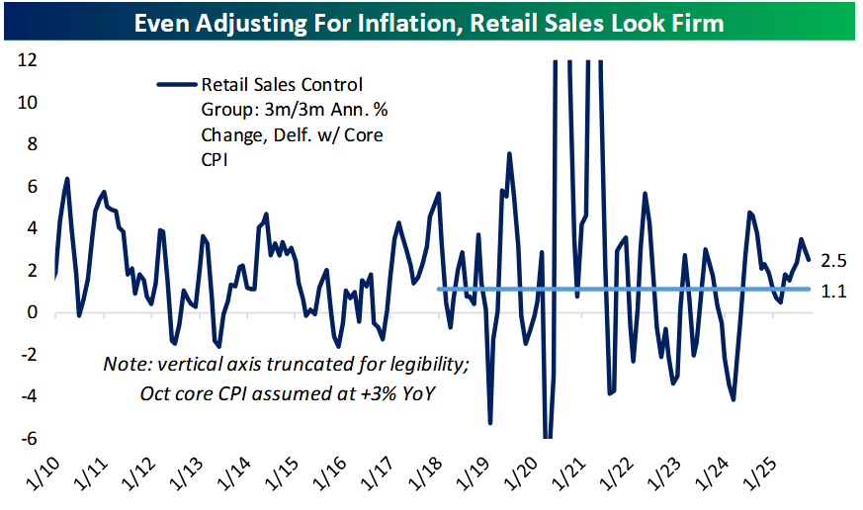
The upper chart shows that core retail sales (ex. Autos, Gas and Building Materials) grew at a 6.1% pace on a 3m/3m annualized basis in November (dark blue line), almost twice as fast as it averaged in the two years prior to the Covid pandemic (light blue horizontal line). Nor is growth just inflation-driven. The bottom chart shows that inflation adjusted retail sales grew at a solid 2.5%, well above the 1.1% pre-pandemic average.

Consumer spending has been the dominant driver of GDP growth in recent quarters and has remained above its pre-COVID average in five of the last six quarters, suggesting the economy is not solely dependent on AI-related investment to sustain its growth. As long as labor markets remain stable, consumer spending can be a durable foundation for a continued expansion.

Source: Bespoke Investment Group

PRO – Moderating Inflation

You can have a heated debate about which way you think inflation is going, but the prevailing trend right now is lower, even though headline inflation remains above the Federal Reserve’s official 2.0% target. Forward-looking inflation “break-evens” show market-based inflation expectations range from 2.3% to 3.1% looking out 30 years. Another inflation data point is the current 10-year US Treasury bond rate of 4.2%, which incorporates investors’ demand for inflation compensation. In the early-1980’s when inflation was a problem, the 10-yr yield rose to over 15.0%. A current 10-yr US Treasury bond yield of 4.2% does not signal inflation is an imminent threat to the expansion. The cleanest way to get a market-implied inflation rate is the US Treasury 10-year breakeven, which accounts for term premium effects. This can be viewed on the St. Louis Fed’s website: fred.stlouisfed.org/series/T10YIE. The latest reading shows that the market expects inflation to average only 2.3% over the next 10 years.

10-Yr Breakeven Inflation Rate: Currently 2.3%
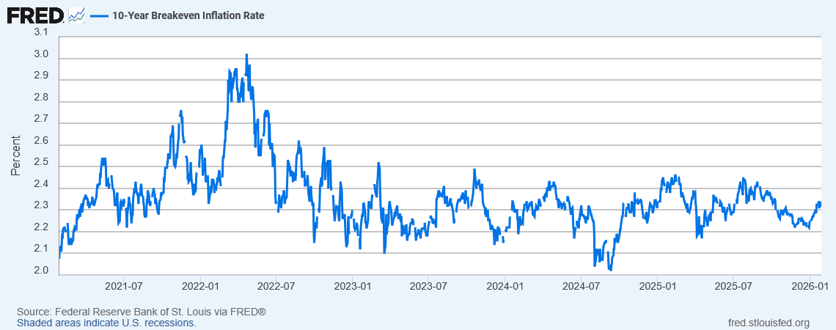

PRO – Strong US earnings

It is often said that earnings are the “mother’s milk” of stock prices since stock prices discount current and future earnings. Year-over-year earnings growth has been outstanding, with full year 2025 and 2026 earnings growth of 12.9% and 17.9% expected, respectively, well above the long-term rate of 8.7%.

PRO – Current Bull Market vs. The Average Post-WW II Bull Market

The S&P 500 remains in a bull market since bottoming back in October 2022. For all periods since 1928, the S&P 500 has been in bull markets (as defined by an upward trend of higher lows and higher highs without an intervening decline of 20%+) 80% of all trading days.

The chart below shows the S&P 500 dating back to 1928. Bull markets are shaded in green while bear markets are highlighted in red. Note that Bull markets have historically been much more prevalent than bear markets. So, if you bet against the market over the long-run, the odds are stacked against you.
Source: Bespoke Investment Group
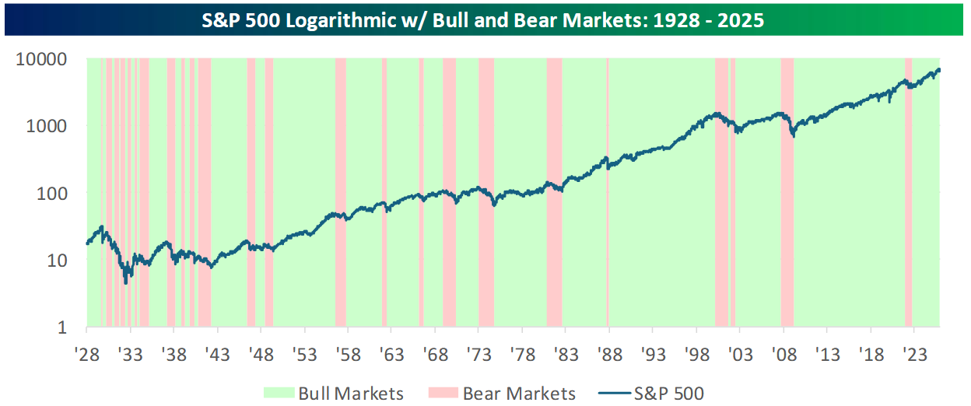
The table to the right shows the gain and duration of all the bull markets since 1928. Note that bull markets have gotten much longer since WW II as American markets have become more developed. The average bull market since 1945 has delivered a gain of 155% over 1,633 days or 4.5 years. The current bull market would extend into April 2027 and see a further gain of about 31% from where it is now to reach the post-WW II average.
Source: VGA, data sourced though Bloomberg

PRO: ChatGPT vs. Netscape

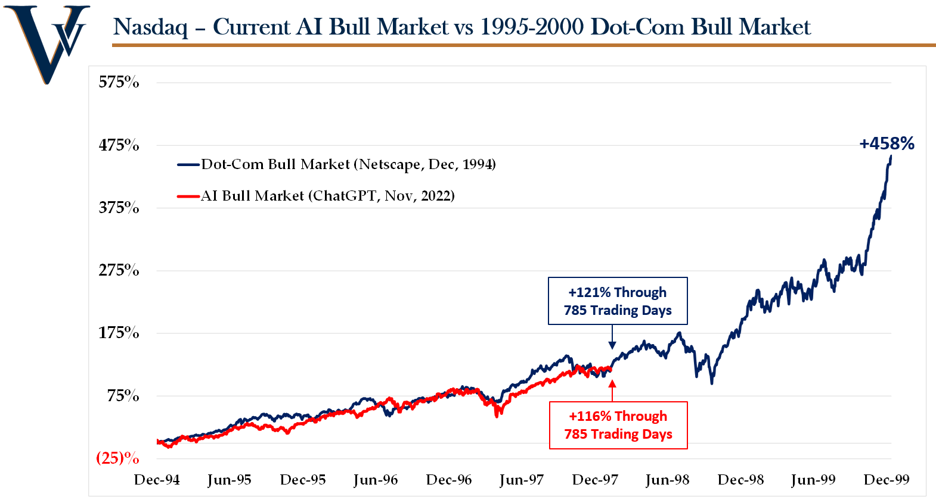
Since ChatGPT’s release in the fall of 2022, the Nasdaq has tracked its performance following the release of the Netscape web browser in December 1994 extremely closely. If this analog continues, there still could be a lot of runway left in the AI boom.
Source: VGA, data sourced though Bloomberg

PRO: Years like 2025

Historically, years that follow years like 2025 have done well. We have shown this analysis before from Haystack AI, a tool that forecasts future price action based on historic trading patterns. The historic periods that most closely resemble 2025’s price action (black line below), project that the S&P 500 will go on to gain 14.7% over the next year with 80% of those instances positive.
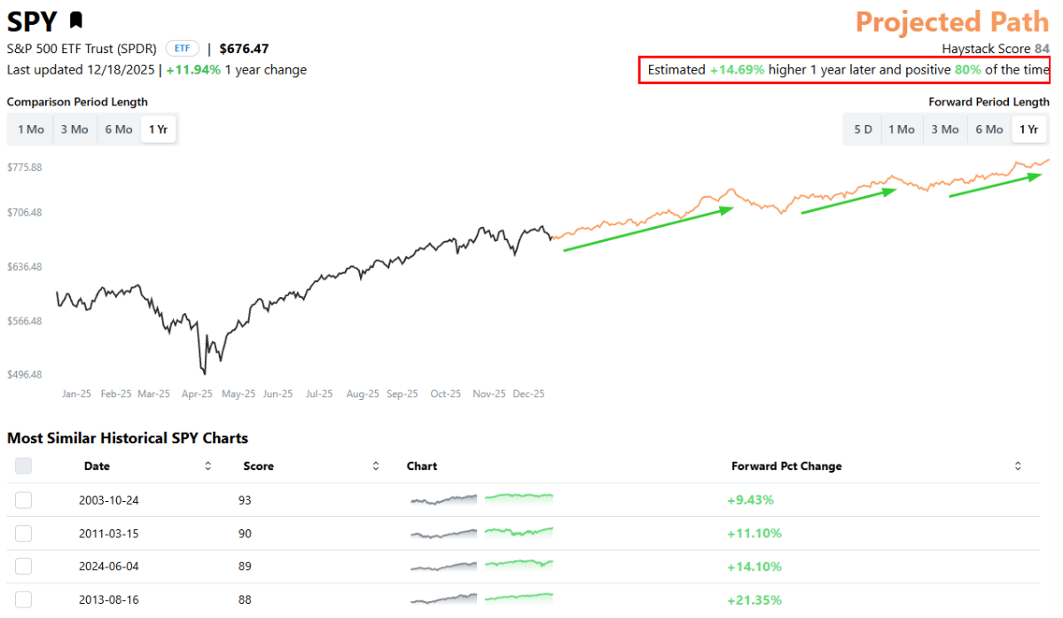
Source: HaystackAI, via Bespoke Investment Group

Risks to the Bull Market

CON: Stretched Valuations

The biggest risk we see for the stock market in 2026 (aside from a black swan event coming out of left field) is: Stretched Valuations.

As shown below in the first chart below, the S&P 500 on a market-cap weighted basis is currently selling for 23.4x forward 12-month earnings compared to its 15-year average of 18.3x. If its valuation were to re-set to its 15-year average, that would imply an 18% decline. However, this market cap-weighted valuation is distorted by the 34% weight of seven large-cap, expensive tech stocks (Mag-7). Looking at the S&P 500 on an equal-weighted basis, it is less expensive. The second chart below shows that the average company in the S&P 500 is currently selling at 19.8x forward 12-month earnings vs. its long-term average of 17.3x. If the average company’s valuation were to reset, it would imply a 13% pullback.

22.3x
18.3x
(18)%

Source: VGA, data sourced though Bloomberg, S&P Global
Source: VGA, data sourced though Bloomberg & S&P Global

Of course, it is our belief that valuation is not a good timing tool. Expensive markets can get more expensive and cheap markets can get cheaper. However, the increasing size of these implied corrections over the past several quarters is making us more concerned about this risk and more willing to add additional cash and/or some hedging should the market reach extreme overbought (and overvalued) status in the first half of 2026.

19.8x
17.3x
(13)%

Source: VGA, data sourced though Bloomberg

CON: Are we in a Bubble? When will it Burst?

In every bubble, valuations increase beyond what fundamentals and cash flows would justify. During the dot-com bubble of 1995-2000, companies went public with no revenues and no idea when they would become profitable. Companies’ stock prices advanced far more than any relation to their earnings growth. For example, Cisco’s stock price increased by 40x from 1995-2000, while its earnings grew only 8x. While we are seeing pockets of froth in both private and public markets today, many AI companies have delivered their market returns through earnings growth. Nvidia’s stock price has increased 14x over the last five years, while its earnings have grown over 20x.

We are watching for signs of a bubble peak that could lead to a valuation bust and a severe bear market decline. When we consider the evidence currently, the ingredients for a market bubble are present. However, the weight of the evidence suggests to us that the risk of a bubble forming in the future is greater than the risk that we are at currently at the height of one right now. Given our preference to invest in profitable companies with reasonable valuations relative to their growth, we continue to find AI exposures from many angles without having to pay anywhere close to the bubble valuations of the dot-com peak.
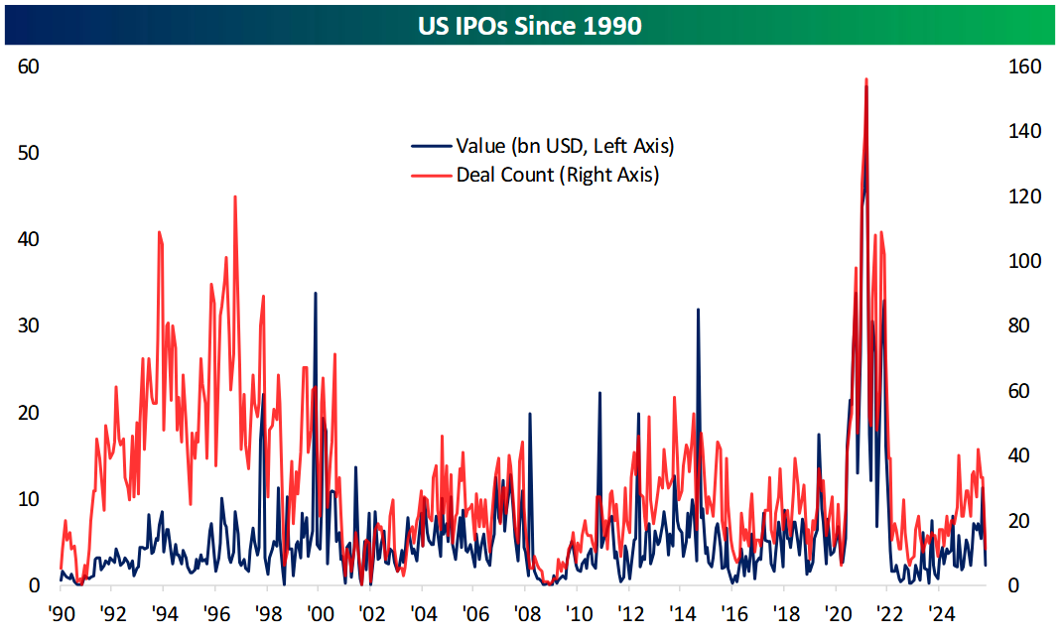
That said, we offer a couple of markers that have served as roadmaps to help determine when a bubble peak is imminent:

- It is Still Early Days for IPO’s

The internet boom was accompanied by a massive increase in Initial Public Offerings (IPO’s). We have yet to see a big increase in new IPO supply during the AI boom since 2022. While companies are staying private longer today than they did 25-30 years ago, we expect to see more AI companies go public before the boom turns into a bubble and an ultimate peak.

Source: Bespoke Investment Group

- Our Macro Models remain Bullish

Our macro models picked up on the 2022 “cloud computing” bubble bursting, when many “cloud darlings” like Zoom, Snowflake and others lost over 80% of their value. We had little exposure to these kinds of stocks given our stock screening approach (GARP, or Growth-at-a-Reasonable-Price) although we added some additional cash and hedging to our strategies in early-2022 to avoid the collateral damage of that bubble bursting that impacted many market indices. Our strategies sustained low-to-mid single digit declines that year vs. the 18% loss of the S&P 500 and 33% loss for the Nasdaq.

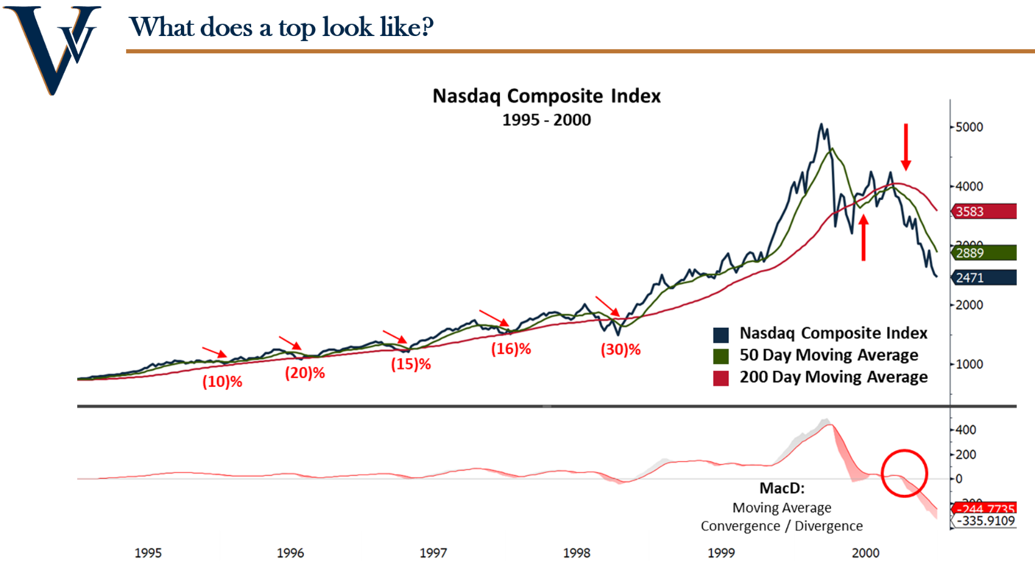
Our macro models rely on a range of indicators to gauge the investment backdrop, but one indicator that has provided a good roadmap for these secular bull markets in tech is whether the Nasdaq continues to trade above a rising 200-day moving average (red line in the chart below) and whether the 50-day moving average (green line) remains above the 200-day, suggesting the broader trend is up. Weekly momentum (as identified by the moving average convergence-divergence indicator or MACD) remaining above 0 also signifies longer-term upward momentum.

Notice how these two indicators broke down hard in late-2000 vs. their constructive positioning during the dot-com bull run from 1995 to early-2000. We will be watching these, and many other indicators in our macro models, closely as the months and quarters play out ahead for signs that irrational exuberance may have peaked and a valuation bubble peak is at hand.

Source: VGA, data sourced though Bloomberg

VGA Positioning for 2026

We will maintain our core GARP discipline in our stock selection process and continue to utilize a “barbell approach” to gain exposure to both secular growth and cyclical value themes (due to the strong economic backdrop). Given our valuation concerns, we expect to raise cash and/or add hedging should the market reach extreme overbought (and overvalued) conditions in 2026.

- Strategic Discipline:
  - GARP Core (Growth at a Reasonable Price)
  - Barbell Approach – Secular Growth and Cyclical Value

Secular Growth: Cyclical Value:
AI Buildout US Homebuilding & Housing Stocks
Power Demand & Electrification Financials - Steepening Yield Curve Beneficiaries
Geopolitical Realignment, Defense & Supply Chain Reshoring Basic Materials
Fintech Consumer Disc – Resilient US Consumer
Industrial Automation
Healthcare Innovation
Cyber Security

- Tactical Discipline:
  - Raise cash / add tactical hedging at extreme overbought conditions
  - Monitor risk metrics on pullbacks for risk of a bear market decline of 20%+

Important Information & Disclosures & Definitions

US Bureau of Economic Analysis
Most recent data from Federal Reserve Bank of Atlanta’s GDPNow forecast tool
Estimates provided by Congressional Budget Office (CBO)
S&P Global 2026 S&P 500 Index earnings analyst estimates
All data for Pro’s and Con’s list provided through Bloomberg, US Federal Reserve, US Bureau of Labor Statistics, US Bureau of Economic Analysis
AI use for firm/investment related activity may pose material which could include but is not limited to the following: Potential biases of the model/tool and potential for AI "hallucinations" that may produce inaccurate results. Potential conflicts of interest that may arise with use of predictive data analytics. Risk that human oversight may not necessarily reduce risk of errors/biases with use of predictive analytics tools. Regulatory risk of future changes to AI-related regulation
Performance generated by Haystack AI is hypothetical in nature and are for illustrative purposes only. Definition of Indices: The S&P 500 Index is a stock market index that tracks the performance of 500 of the largest publicly traded companies in the United States. It is market-capitalization-weighted, meaning companies with a larger market value have a greater impact on the index. The S&P 500 is widely used as a benchmark for the U.S. equity market and provides a broad representation of various sectors of the economy, including technology, healthcare, financials, and consumer goods. It is often used by investors to gauge overall market performance and to compare the returns of individual investment portfolios. This document contains performance data that references the S&P 500 Index (the "Index"). The S&P 500 Index is a market capitalization-weighted index of 500 of the largest publicly traded companies in the U.S. and is widely regarded as a benchmark for the U.S. equity market. Please note that the S&P 500 Index is unmanaged and does not include transaction costs, fees, or expenses associated with the purchase or sale of securities. Unlike the performance of the Fund, which may be subject to fees, the performance of the Index does not reflect the impact of these costs. Index returns are typically gross returns, unless otherwise specified. Past performance of the Fund or its manager is not indicative of future results, and there can be no assurance that the Fund will outperform or track the performance of the S&P 500 Index or any other benchmark. The S&P 500 Index is used solely for comparison purposes and does not reflect any investment strategy or portfolio. It is not possible to directly invest in the S&P 500 Index. The Equal Weighted S&P 500 Index (the “Index”) is an equal-weighted version of the S&P 500 Index, which is a market capitalization-weighted index of 500 leading publicly traded companies in the United States. Unlike the market capitalization-weighted S&P 500 Index, where each constituent’s weight is proportional to its market value, the Index assigns an equal weight to each of the 500 constituent stocks at the time of each quarterly rebalance. The Index includes the same 500 constituent companies as the S&P 500 Index. At each quarterly rebalance, each constituent is assigned a weight of approximately 0.20% (representing 1/500th of the Index). This equal weighting methodology results in greater exposure to smaller companies within the S&P 500 universe compared to the traditional market capitalization-weighted S&P 500 Index, and correspondingly less exposure to the largest companies by market capitalization. Please note that the Equal Weighted S&P 500 Index is unmanaged and does not include transaction costs, fees, or expenses associated with the purchase or sale of securities. Past performance of the Index is not indicative of future results. The performance of the Index will depend on the performance of its constituent securities and the effects of quarterly rebalancing. The Index’s equal weighting methodology will cause its performance to differ, potentially significantly, from the performance of the market capitalization-weighted S&P 500 Index, particularly during periods when large-capitalization stocks outperform or underperform small and mid-capitalization stocks. The Nasdaq Composite Index (the “Index”) is a broad-based market capitalization-weighted index of all common stocks listed on The Nasdaq Stock Market. The Index was established with a base value of 100 on February 5, 1971, and includes domestic and international securities across all market capitalization sizes. The Index is designed to represent the performance of the Nasdaq stock market and serves as a benchmark for technology and growth-oriented stocks. The Index includes all domestic and international common stocks, ordinary shares, American Depositary Receipts (ADRs), shares of beneficial interest or limited partnership interests, and tracking stocks listed on The Nasdaq Stock Market. As of recent data, the Index includes over 3,000 constituents, making it one of the most comprehensive equity indices available. To be eligible for inclusion in the Index, securities must be listed on The Nasdaq Stock Market. The Index excludes closed-end funds, convertible debentures, exchange-traded funds (ETFs), preferred stocks, rights, warrants, units, and other derivative securities. The Index has historically had significant exposure to technology-related sectors, including information technology, communication services, and consumer discretionary companies. However, the Index encompasses companies from all sectors of the economy. The sector composition of the Index changes over time based on the performance and market capitalization of constituent companies, as well as new listings and delistings. Investors should note that the Index’s concentration in technology and growth-oriented companies may result in greater volatility compared to more diversified market indices. Securities of companies in bankruptcy proceedings are removed from the Index. The Index is a market capitalization-weighted index, meaning each constituent’s weight is proportional to its total market value. The market capitalization of each security is calculated by multiplying the security’s last sale price by the number of shares outstanding. Larger companies by market capitalization have a greater impact on the Index’s performance than smaller companies. The Index is calculated on a real-time basis during market hours and is disseminated once per second. Past performance of the Index is not indicative of future results. The performance of the Index will depend on the performance of its constituent securities and the effects of quarterly rebalancing. Important Information & Disclosures & Definitions cont. Vineyard Global Advisors LLC is a dba of Integrated Advisors Network, LLC (“Integrated”) which is a registered investment adviser with the Securities and Exchange Commission. Registration does not imply a certain level of skill or training. collectively hereinafter (“the Adviser” or “Vineyard Global Advisors” or “VGA”) was founded in 2015. The information provided by VGA (or any portion thereof) may not be copied or distributed without VGA’s prior written approval. We have provided this information regarding your account(s) based on sources we believe to be accurate, and is provided for informational purposes only. No representations are being made as to the accuracy or completeness of this material. To ensure accuracy, you are encouraged to compare account information detailed on this statement with the information contained on your custodial statement from the corresponding time period. Please contact us or the account custodian with any questions you may have. Also, please notify us promptly if you do not receive statements on all accounts from the custodian on at least a quarterly basis. The information provided should be used only as a general guide to portfolio values. Statements are current as of the date of the material only. Current investment allocations may not be the same as depicted, as they are in the discretion of the investment manager. Portfolios are subject to change without notice and may not be representative of current or future allocations. You should not assume that investment decisions we make in the future will be profitable or will equal the investment performance of the past. All statements are current as of the date written and does not constitute an offer or solicitation to any person in any jurisdiction in which such offer or solicitation is not authorized or to any person to whom it would be unlawful to make such offer or solicitation. The standard fee schedules is shown in VGA’s Form ADV Part 2. The Advisor and its affiliates do not provide tax advice, and as such the figures presented should not be relied upon for tax purposes. Accordingly, any discussion of U.S. tax matters contained herein (including any attachments) is not intended or written to be used, and cannot be used, in connection with the promotion, marketing or recommendation by anyone unaffiliated with Integrated of any of the matters addressed herein or for the purpose of avoiding U.S. tax-related penalties. Past results are not necessarily indicative of future performance and are no guarantee that losses will not occur in the future. Investing involves risk, future returns are not guaranteed and a loss of principal may occur. There is no guarantee that these measurements will be achieved. Any performance shown is compared to several indexes shown herein. Broad-based securities indices are unmanaged and are not subject to fees and expenses typically associated with managed accounts or investment funds. The number and types of securities found in the index can differ greatly from that of the accounts held in the strategy shown. Investments cannot be made directly in an index. The estimated fair values of certain alternative investments, which may include private placements and other securities for which prices are not readily available, are determined by the general partner or sponsor of the alternative investment and may not reflect amounts that could be realized upon immediate sale, nor amounts that ultimately may be realized. Accordingly, the estimated fair values may differ significantly from the values that would have been used had a ready market existed for these investments. The fair value of these investments generally represents the amount the general partner or sponsor would expect to receive if it were to liquidate its investment in underlying assets, excluding any redemption charges that may apply. Important Information & Disclosures & Definitions cont. Model Performance – See Additional Strategy Specific Disclosures Some of the performance information provided in this document is modeled simulated performance (“modeled performance”) produced by a model following what is believed to be a materially similar strategy as will be utilized by Vineyard Global Advisors. It does not represent the actual performance of any fund or account and no investor has experienced these results. Model performance represents the results of a model investment portfolio, and includes performance results generated by a model portfolio managed with the same investment philosophy used by the adviser for actual client accounts and consisting of the same securities recommended by the adviser to clients during the same time period, with variances in specific client objectives being addressed via the asset allocation process (i.e., the relative weighting of stocks, bonds, and cash equivalents in each account). This type of performance is hypothetical because although the model consists of the same securities held in client accounts, the asset allocation process results in performance results that were not actually achieved by any client. Models are often designed to represent the appropriate balance of securities for a client’s portfolio based on defined investment objectives and risk tolerance. Models do not reflect actual trading, and therefore, do not reflect the impact that economic and market factors including concentration, lack of liquidity or market disruptions, may have on investment decisions. Actual events are difficult to predict and are beyond the control of Vineyard Global Advisors. Actual events may be different, perhaps materially, from those assumed. The information contained herein does not purport to contain all of the information that may be required to evaluate the investment strategy and you should conduct your own independent analysis of the data referred to herein. The actual performance of any fund or account managed by Vineyard Global Advisors may be materially different from the modeled performance shown for a number of reasons including (i) differences in net asset values and expenses ratios, (ii) differences in the portfolio, fees, commissions and dividend accounting, (iii) permitted underlying securities and investment guidelines, (iv) different valuation methodologies and liquidity terms, and (v) changes in trading strategy over time. In particular, the modeled performance shown do not reflect any management or incentive fees, while any investment product offered by VGA will be subject to management fees and may be subject to incentive fees. Actual returns will be reduced by investment advisory fees and other expenses that may be incurred. The periodic deduction of fees produces a compounding effect on the total rate of return net of management fees. There is no certainty or representation made that any investment product or account’s performances will be or would have been similar to the modeled performance provided. The use of the modeled performance is provided solely for informational purposes and should not serve as the basis for a determination to invest in any investment product or account. Benchmarks and financial indices are shown for illustrative purposes only and are provided for the purpose of making general market data available as a point of reference only. Such benchmarks and financial indices are unmanaged, assume reinvestment of income, do not reflect the impact of any trading commissions and costs, management and incentive fees, and have limitations when used for comparison or other purposes because they, among other reasons, may have a different trading strategy, volatility, credit or other material characteristics (such as limitations on the number and types of securities or instruments). No representation is made that any benchmark or index is an appropriate measure of comparison. Figures assumed that dividends and other income were reinvested. Back Tested Results Any back-tested results based on simulated or hypothetical performance have certain inherent limitations. Unlike the results shown in an actual performance record, these results do not represent actual trading. Also, because these trades have not actually been executed, these results may have under-or over-compensated for the impact, if any, of certain market factors, such as lack of liquidity. Simulated or hypothetical trading programs in general are also subject to the fact that they are designed with the benefit of hindsight. No representation is being made that any account will or is likely to achieve profits or losses similar to these being shown. Any case studies are intended to illustrate products and services available through VGA. They do not necessarily represent the experience of other clients nor do they indicate future performance. Important Information & Disclosures & Definitions cont. Research/Outlook Disclosure: This information was produced by and the opinions expressed are those of VGA as of the date of writing and are subject to change. Any research is based on VGA proprietary research and analysis of global markets and investing. The information and/or analysis presented have been compiled or arrived at from sources believed to be reliable, however VGA does not make any representation as their accuracy or completeness and does not accept liability for any loss arising from the use hereof. Some internally generated information may be considered theoretical in nature and is subject to inherent limitations associated therein. There are no material changes to the conditions, objectives or investment strategies of the model portfolios for the period portrayed. Any sectors or allocations referenced may or may not be represented in portfolios of clients of VGA, and do not represent all of the securities purchased, sold or recommended for client accounts. Due to differences in actual account allocations, account opening date, timing of cash flow in or out of the account, rebalancing frequency, and various other transaction-based or market factors, a client’s actual return may be materially different than those portrayed in the model results. The reader should not assume that any investments in sectors and markets identified or described were or will be profitable. Investing entails risks, including possible loss of principal. The use of tools cannot guarantee performance. Past performance is no guarantee of future results. The information provided may contain projections or other forward-looking statements regarding future events, targets or expectations, and is only current as of the date indicated. There is no assurance that such events or targets will be achieved, and may be significantly different than that shown here. The information presented, including statements concerning financial market trends, is based on current market conditions, which will fluctuate and may be superseded by subsequent market events or for other reasons. Market indexes are included in this report only as context reflecting general market results during the period. VGA may trade in securities that are not represented by such market indexes and may have concentrations in a number of securities and in asset classes not included in such indexes. Accordingly, no representations are made that the performance or volatility of the model allocations will track or reflect any particular index. Market index performance calculations are gross of management and performance incentive fees. The charts depicted within this presentation are for illustrative purposes only and are not indicative of future performance. The data do not reflect the material differences between stocks, bonds, bills and inflation, such as fees (including sales and management fees), expenses or tax consequences. Common stocks generally provide an opportunity for more capital appreciation than fixed income investments but are also subject to greater market fluctuations. Corporate bonds, US Treasury bills and US government bonds fluctuate in value but, if held to maturity, offer a fixed rate of return and a fixed principal value. Government securities are guaranteed as to the timely payment of interest and provide a guaranteed return of principal. The principal value and interest on treasury securities are guaranteed by the US government if held to maturity. Investors cannot directly invest in an index. Actual results may vary based on an investor’s investment objectives and portfolio holdings. Investors may need to seek guidance from their legal and/or tax advisor before investing. To the extent the investments discussed herein represent international securities, you should be aware that there may be additional risks associated with international investing involving foreign economic, political, monetary and/or legal factors. International investing may not be for everyone. Municipal Bonds may be subject to state and local taxes, and/or the alternative minimum tax and capital gains tax. May be worth less or more than face value if sold prior to maturity. Important Information & Disclosures & Definitions cont. Investment advisory services are provided through Integrated Advisors Network, LLC (“Integrated”) a registered investment advisor. Registration does not imply a certain level of skill or training. Vineyard Global Advisors, LLC is a practice group of Integrated. The opinions expressed herein are those of Vineyard Global Advisors and are subject to change without notice. This material is not financial advice or an offer to sell any product. Forward-looking statements cannot be guaranteed. This document may contain certain information that constitutes “forward-looking statements” which can be identified by the use of forward-looking terminology such as “may,” “expect,” “will,” “hope,” “forecast,” “intend,” “target,” “believe,” and/or comparable terminology. No assurance, representation, or warranty is made by any person that any of Vineyard’s assumptions, expectations, objectives, and/or goals will be achieved. Nothing contained in this document may be relied upon as a guarantee, promise, assurance, or representation as to the future. Vineyard Global Advisors is an investment adviser registered with the U.S. Securities and Exchange Commission. Registration does not imply a certain level of skill or training. Investment advisory services offered through Integrated Advisors Network, LLC (“Integrated), a registered investment advisor. Vineyard Global Advisors is a DBA of Integrated. There is no guarantee that the investment objectives will be achieved. Moreover, past performance is not a guarantee or indicator of future results. Does not constitute advice or a recommendation or offer to sell or a solicitation to deal in any security or financial product. It is provided for information purposes only and on the understanding that the recipient has sufficient knowledge and experience to be able to understand and make their own evaluation of the proposals and services described herein, any risks associated therewith and any related legal, tax, accounting or other material considerations. Integrated is registered with the Securities and Exchange Commission (SEC). Registration of an investment adviser does not imply any specific level of skill or training and does not constitute an endorsement of the firm by the Commission. Business is only transacted in states in which it is property registered or is excluded or exempted from registration. A copy of Integrated's and VGA's current written disclosure brochure filed with the SEC which discusses among other things, business practices, services and fees, is available through the SEC's website at: www.adviserinfo.sec.gov

